**Rose Ciriello**

**30 October 2019**

**Assignment 6 – Adding Functionality to a Website with JS**

**Low Fidelity Prototype**

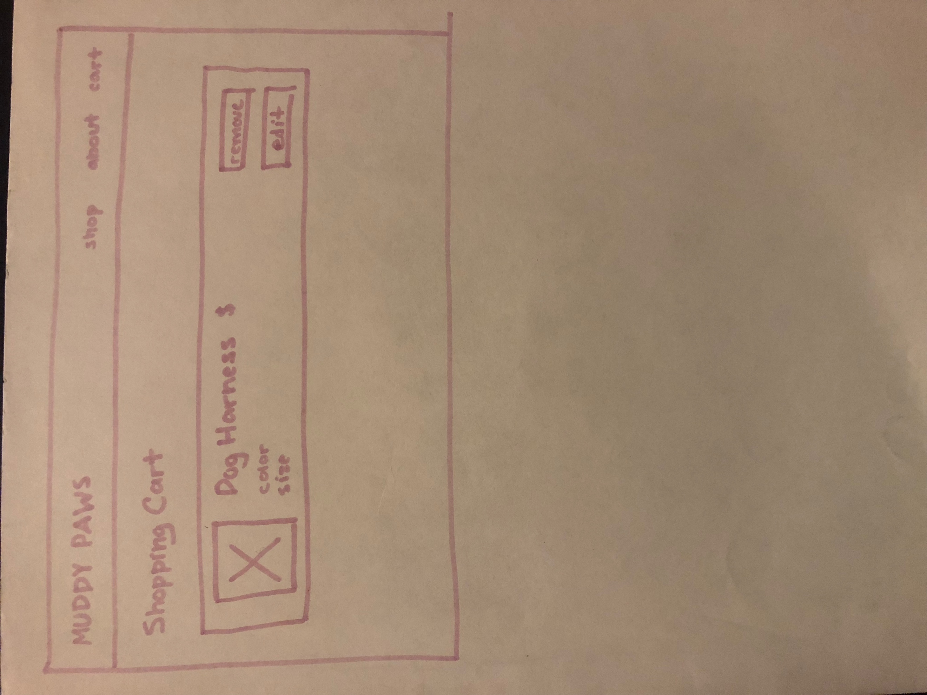

For the shopping cart page, I wanted to stick with the same simple, geometric layout I had been using for the other pages. Based on an earlier sketch, I included the navigation menu at top, a clear shopping cart label, and an item card. The only information that changed slightly was on the item card, which now prioritizes size and color selected. It also offers “remove” and “edit” functions as opposed to “details” and “edit” functions, which are more clearly separate actions, and allows for easy one-click removal of an item from the cart.

**High Fidelity Prototype**

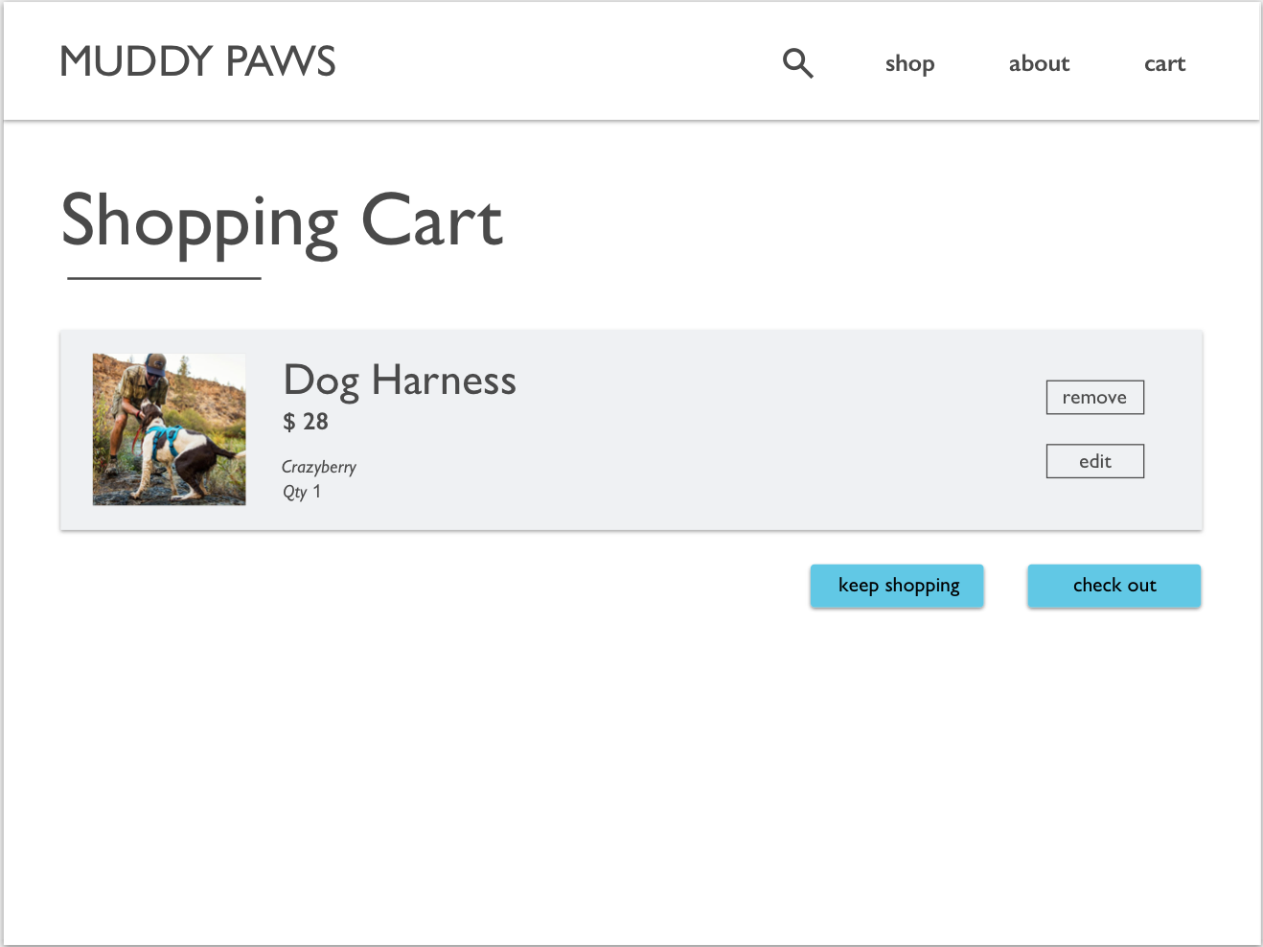

This high fidelity mock up is based closely on the low fidelity model above. The main difference is that the low-fi version unintentionally did not include a checkout or continue shopping, which are now included so the user has a clear indication of where to go next.

**Reflection**

This was a challenging assignment for me. The biggest roadblock that I kept running into was syntax errors. While I knew what I wanted my code to accomplish, I often didn’t know where to start in terms of expressing it in JavaScript. When dealing with these types of errors, the first place I checked for help was labs the past few weeks, then W3Schools, which helped a lot in identifying any punctuation or arguments I was missing. One place in particular I experienced this was when adding items to local storage. I wasn’t sure how to properly construct a for loop in Javascript, but a combination of TA office hours, labs, and internet searching set me on the right track. Trial and error proved my best friend for this homework.

**External Sources**

https://www.w3schools.com/

https://www.abeautifulsite.net/adding-and-removing-elements-on-the-fly-using-javascript

https://store.adventurecats.org/products/puppia-cat-harness

https://ruffwear.com/products/web-master-harness

http://www.spanishdict.com/answers/285146/la-palabra-del-da-soleado

http://boshel.com/product/dog-travel-water-bottle/

https://www.popsugar.com/pets/Adventure-Cats-Hiking-Instagram-42244812

https://blog.gopetfriendly.com/how-to-manage-greetings-when-hiking-with-cats/

https://hiconsumption.com/2018/02/best-hiking-dog-harnesses/

https://www.rei.com/learn/expert-advice/hiking-dogs.html

https://www.digitaltrends.com/outdoors/best-hiking-gear-for-dogs/